Name of Student : Raghav Mahesh Sarda PRN: 25070122235
Subject: Programming with Java Semester: III
ASSIGNMENT No : 19 Year: AY 2026-27
TITLE : JDBC SELECT Operation

Problem Statement
Develop a Java application to establish connectivity with a database and perform data retrieval using the SELECT operation.

Learning Objectives
To establish database connectivity and retrieve records using JDBC SELECT statements.

Program:
sit_java.sql
CREATE DATABASE sit_java;
USE sit_java;

-- Table for Exercise 1
CREATE TABLE student (
roll_no INT PRIMARY KEY,
name VARCHAR(50),
course VARCHAR(50),
marks DOUBLE
);

INSERT INTO student VALUES
(101, 'Raghav Sarda', 'Computer Science', 92.5),
(102, 'Parth Kulkarni Sarda', 'Computer Science', 94.5),
(103, 'Yatharth Shah', 'Computer Science', 93.5);

-- Table for Exercise 2
CREATE TABLE product (
product_id INT PRIMARY KEY,
product_name VARCHAR(50),
quantity INT,
price DOUBLE
);

INSERT INTO product VALUES
(501, 'Logitech MX Master 4 Mouse', 10, 16000),
(502, 'Apple Magic Keyboard', 20, 18000),
(503, 'Apple Studio Display', 15, 179999);

StudentSelect.java
// Assignment 19 - Exercise 1: Display Student Records using SELECT Query
import java.sql.*;
public class StudentSelect
{
public static void main(String args[]) // Main method
{
String url = "jdbc:mysql://localhost:3306/sit_java"; // Database URL
String user = "thegharkalaptop"; // DB Username
String pass = ""; // DB Password

try // Exception handling for JDBC
{
Class.forName("com.mysql.cj.jdbc.Driver"); // Registering JDBC driver
Connection con = DriverManager.getConnection(url, user, pass); // Establishing connection
Statement stmt = con.createStatement(); // Creating Statement object

String query = "SELECT roll_no, name, course, marks FROM student"; // SQL SELECT query
ResultSet rs = stmt.executeQuery(query); // Executing query and getting ResultSet

System.out.println("== Student Records from Database ==");
System.out.println("Roll No\tName\t\tCourse\t\tMarks");

while(rs.next()) // Iterating through cursor row by row
{
int roll = rs.getInt("roll_no");
String name = rs.getString("name");
String course = rs.getString("course");
double marks = rs.getDouble("marks");

System.out.println(roll + "\t" + name + "\t" + course + "\t" + marks); // Printing row
}

rs.close(); // Closing ResultSet
stmt.close(); // Closing Statement
con.close(); // Closing Connection
}
catch(Exception e) // Catching SQL and Driver exceptions
{
System.out.println("Database Error: " + e.getMessage());
}
}
}

ProductSelect.java
// Assignment 19 - Exercise 2: Connect to DB and display product details using SELECT
import java.sql.*;
public class ProductSelect
{
public static void main(String args[]) // Main Method
{
String url = "jdbc:mysql://localhost:3306/sit_java"; // Database URL
String user = "thegharkalaptop"; // DB Username
String pass = ""; // DB Password

try // Try block
{
Class.forName("com.mysql.cj.jdbc.Driver"); // Registering driver
Connection con = DriverManager.getConnection(url, user, pass); // Connecting to DB
Statement stmt = con.createStatement(); // Creating statement

String query = "SELECT product_id, product_name, quantity, price FROM product"; // SELECT query
ResultSet rs = stmt.executeQuery(query);

System.out.println("== Product Inventory List ==");
System.out.println("ID\tProduct Name\t\tQuantity\tPrice ($)");

while(rs.next()) // Traversing ResultSet
{
int pid = rs.getInt("product_id");
String pname = rs.getString("product_name");
int qty = rs.getInt("quantity");
double price = rs.getDouble("price");

System.out.println(pid + "\t" + pname + "\t" + qty + "\t\t" + price); // Displaying record
}

rs.close(); // Closing ResultSet
stmt.close(); // Closing Statement
con.close(); // Closing Connection
}
catch(Exception e) // Catching exceptions
{
System.out.println("Error: " + e.getMessage());
}
}
}

Output:
StudentSelect.java & ProductSelect.java
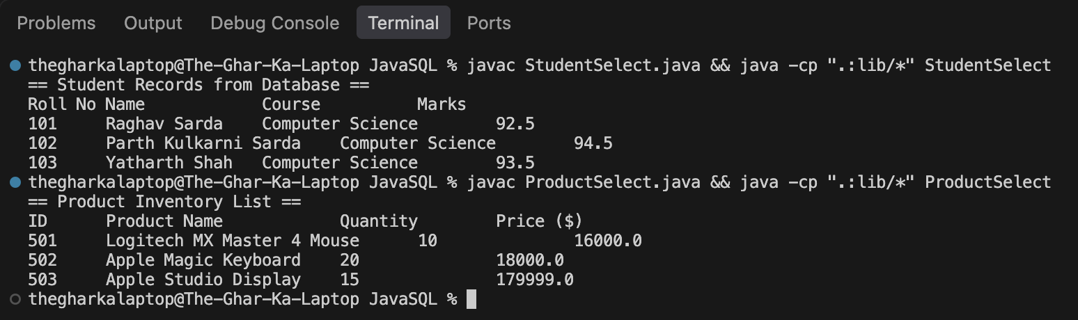

Conclusion:
In this assignment, database connectivity and sequential data retrieval using the JDBC SELECT operation were successfully implemented and verified. The DriverManager class established a live session with the MySQL database, the Statement interface executed SQL query strings, and the ResultSet interface enabled row-by-row cursor navigation to extract and format tabular data.

